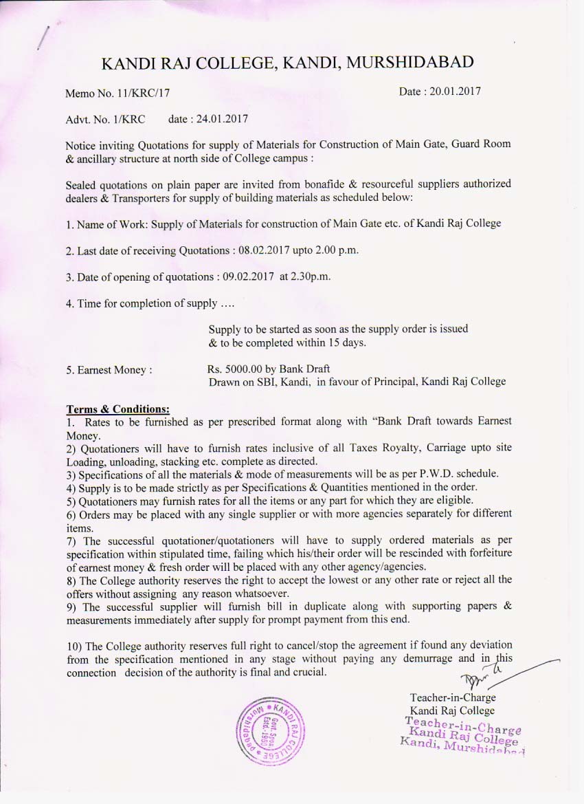

KANDI RAJ COLLEGE, KANDI, MURSHIDABAD
Construction of Main Gate Security Room etc.

SCHEDULE OF ITEMS & FORMAT FOR SUBMISSION OF RATES:

Description of items Quantities UnitRate Remark:
01. First Class Chimney burnt Bricks 8300 Nos. 1000 Nos. ………………

02. Coarse Sand 900 cft. 100 Cft. ……………….

03. Stone metal 40mm to 25 mm 150 Cft. 100 Cft. ………………..

04. Stone Chips 6mm to 20mm graded
(20mm nominal size 60% 10mm 40%) 470 Cft. 100 Cft. ……………….
05. Cement PSC/PPC
Laferge/Ambuja/Birla Gold/Jaypee 200 Bags 1bag(50Kg) ………………

06. Steel Reinforcement Bars
(8 top 16 mm dia) 15.30Quintal Quintal ………………
(Tata/Elegamt/SQMB/orsimilar(ISI marked)

07. Unsliced stone Lime l 170Kg. Kg. ………………..

08. Steel Door & Windows with M.S. Sheet
Panels & integrated grills as per design. 57. Sq.ft. Kg. …………………..
09. Ornamental Grill Gate
With M.S. Hollow section, angle, sq.bars,
Flat, plate etc. as per design 176 sq.ft. (490 Kg.approx) Kg. ………………………..

10. 15 to 18 mm thick granite slab. 125 sq. ft. Sq.ft. ………………………..

11. 50 mm Thick decorative coloured
Cement Concrete pavement Blocks 330 sq.ft. Sq.ft. ………………………..

12. Local Sand 200 Cft. 100 cft. ………………………..

